Software Requirements Specification (SRS) for E-commerce Project

# INTRODUCTION:

## Purpose

The purpose of this SRS document is to provide a detailed outline of the functionalities, features, system constraints, and user interface of the “ShopSmart” e-commerce platform. “ShopSmart” is designed to enable customers very comfortable buying experience and accessible online shopping experience to a wide range of customers.

# OVERALL DESCRIPTION:

## Product Perspective

## Product Features

## User Classes and Characteristics

# System Features

## Account

* The application should allow users to create a new account using basic information, email(all emails are unique), and password...
* The application should disabled all newly created accounts unit verified.
* The application should send an email with a link to comfirm new user account.
* Only after verifying a new account should a user be able to log into the application.

## Reset Password

* The application should allow users to reset their password.
* The application should send a link to user's email to reset their password (link to be invalid after being clicked on).
* The application should present a screen with a form to reset password when the link is clicked.
* If a password is reset successfully, user should be able to log in using the new password.
* The application should allow users to reset their password as many times as they need.

## Category

* The application should allow the admin to add categories as many as he wants.
* The application should allow the admin to update any category.
* The application should allow the admin to delete any category.
* The application should allow only the admin to deal with the category.
* The application should allow the admin to view all the categories in one page.

## Product

* The application should allow the admin to add any number of products for just one category.
* The application should allow the admin to delete any product.
* The application should allow the admin to update any product.
* The application should allow the admin to view all products in one category.
* The application should allow the customer to show a product in a category.
* The application should make sure that the only one deals with the product is the admin.

# External Interface Requirements

### User Interfaces (Front-end) Requirements

1. **Nice Front End**:
   * The front end of the E-commerce application must have an aesthetically pleasing design.
   * Use a clean and modern layout with attention to typography, color schemes, and visual consistency.
   * Ensure that the UI elements (buttons, forms, navigation bars) are visually appealing and aligned with the overall theme.
2. **User-Friendly Widgets**:
   * The widgets (components) used in the UI should enhance the user experience and make interactions intuitive.
   * Consider the following user-friendly widgets:
     + **Navigation Menu**:
       - Clear and organized navigation menu with categories, search, and user account links.
     + **Product Listings**:
       - Display products in a grid or list format.
       - Include product images, names, prices, and brief descriptions.
     + **Search Bar**:
       - An easily accessible search bar for users to find products quickly.
     + **Shopping Cart Widget**:
       - Show the number of items in the cart.
       - Provide a link to view the full cart.
     + **Product Details Page**:
       - Detailed information about a selected product.
       - Include product images, specifications, and customer reviews.
     + **User Authentication Forms**:
       - User-friendly login and registration forms.
     + **Order Summary Widget**:
       - Display order details (items, quantities, total amount) during checkout.
     + **Responsive Design**:
       - Ensure the UI adapts well to different screen sizes (desktop, tablet, mobile).
3. **Accessibility**:
   * Design the UI with accessibility in mind:
     + Use semantic HTML tags.
     + Provide alt text for images.
     + Ensure proper keyboard navigation.
     + Maintain sufficient color contrast for readability.
4. **Consistent Design Patterns**:
   * Maintain consistency across pages:
     + Use the same fonts, colors, and button styles.
     + Keep the layout consistent (e.g., header, footer, content area).
     + Apply consistent spacing and alignment.

# Nonfunctional Requirements

## Performance Requirements

* + The application should show the all categories to admin and the user in order of seconds.
  + The application should be able to make the users register in the system in order of 1second.
  + The application should be able to make the customers login in the system in order of 1second.
  + The application should be able to make the customers make the payment in order of seconds.
  + The application should be able to make the customers view the product in just milliseconds.

## Safety Requirements

* + All user data collected by the application must be handled safely, ensuring that accidental data leaks do not occur. Implement measures to secure data at rest and in transit.
  + The system must handle operational errors smoothly without causing system crashes or data loss. Proper error handling mechanisms must be in place to ensure stability.
  + The system should be robust against faults and continue to operate under predefined failure conditions. Implement redundancy for critical components to maintain system availability.

## Security Requirements

* + All sensitive data, including user credentials and payment information, must be encrypted using strong encryption protocols both at rest and in transit.
  + Implement strong, multi-factor authentication mechanisms for users, especially for accessing sensitive features like account settings and payment information.
  + Define and enforce strict user roles and permissions to ensure users can only access data and perform actions appropriate to their roles.
  + Ensure secure session management by implementing timeouts and re-authentication for sensitive actions.

## Use Case Diagrams

## 

## Activity Diagrams

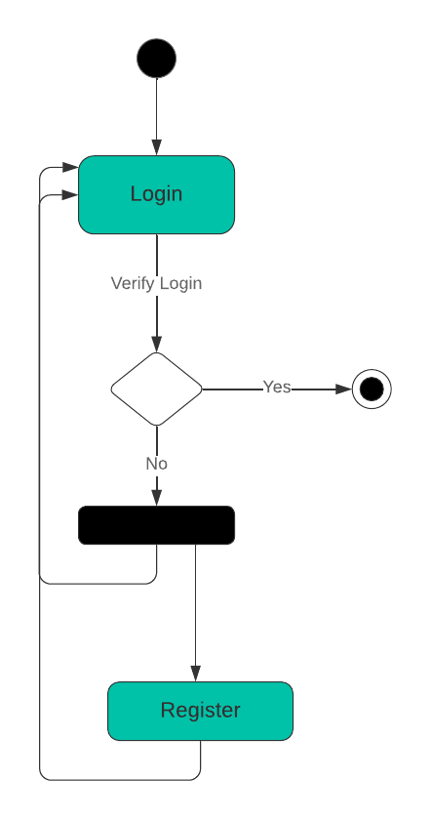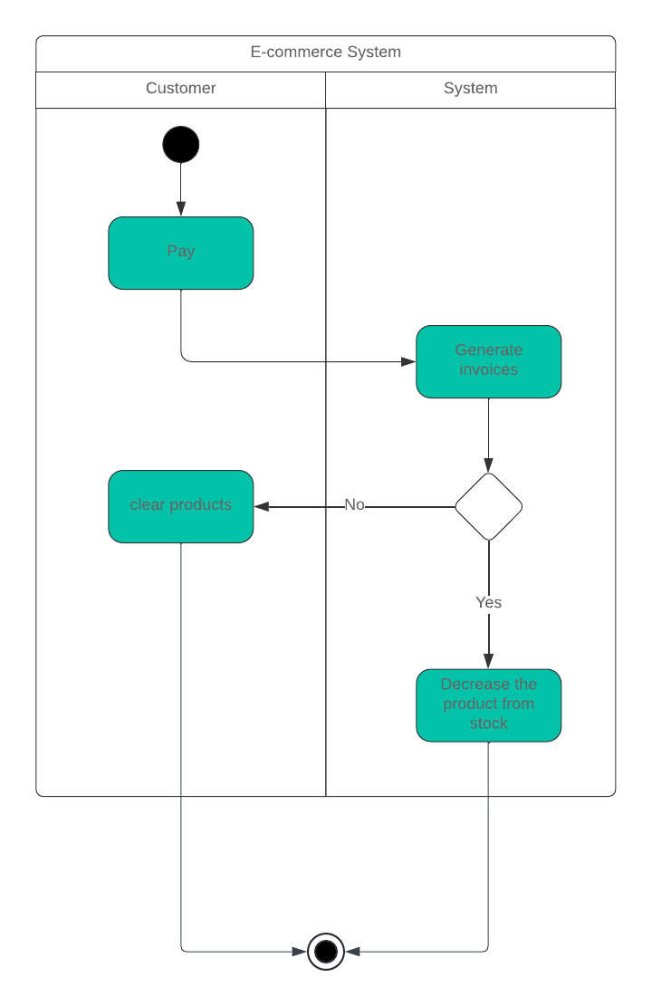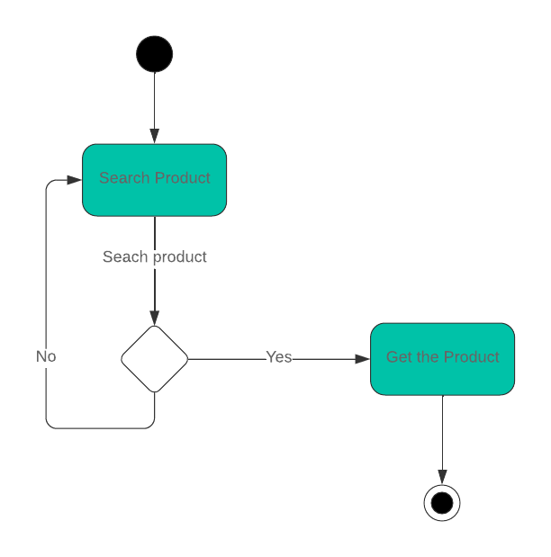

## Sequence diagrams

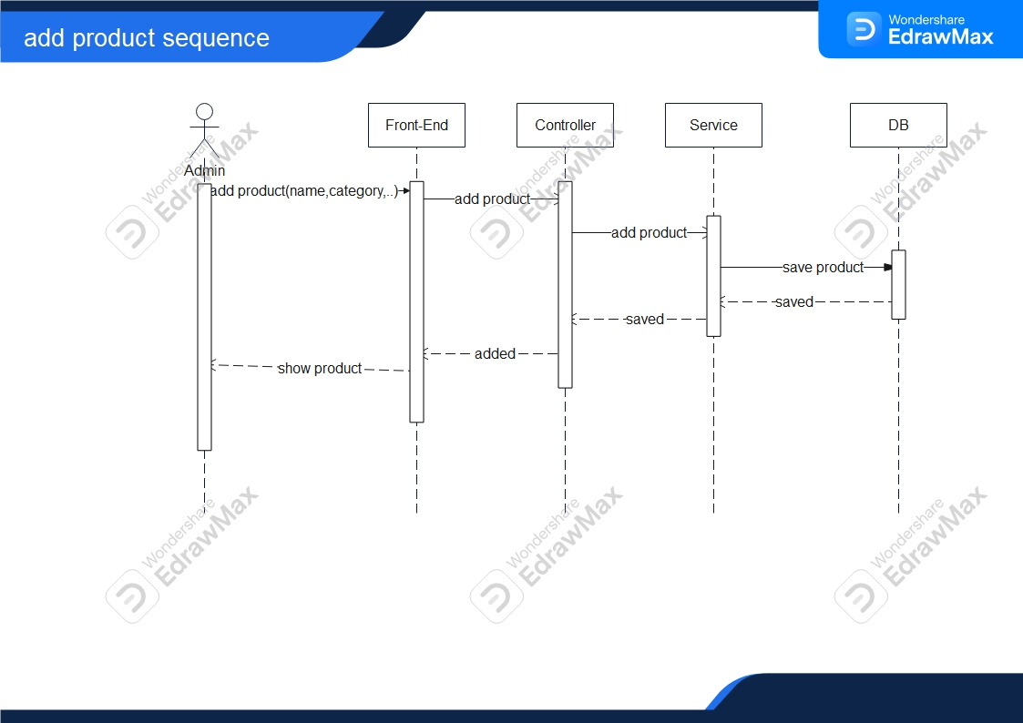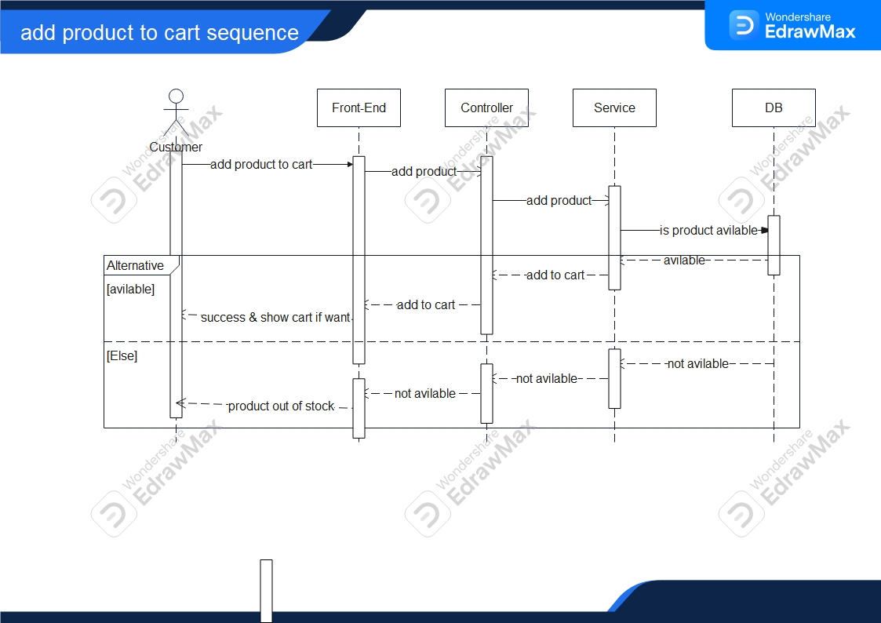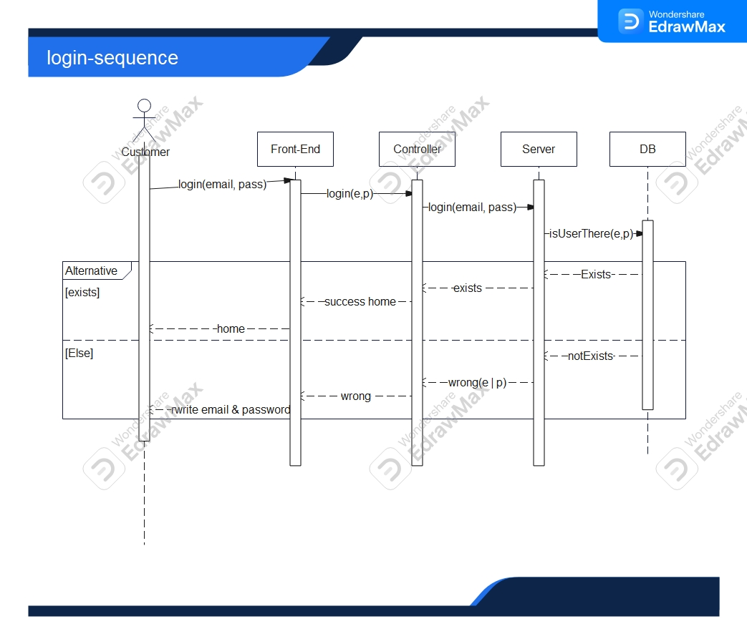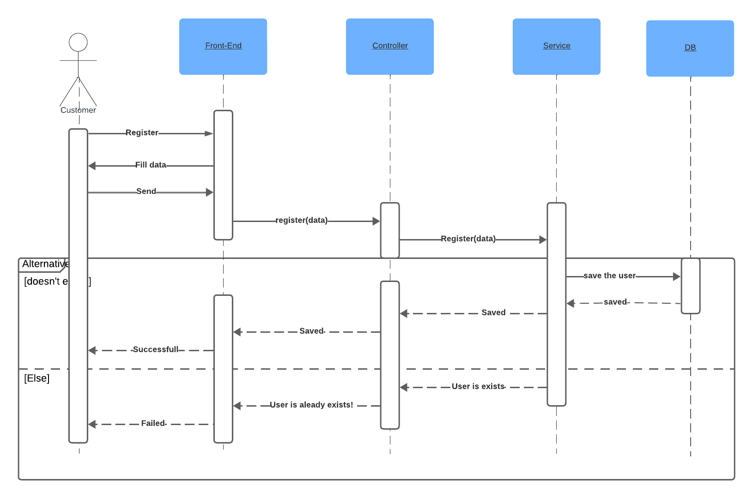

## Class Diagram

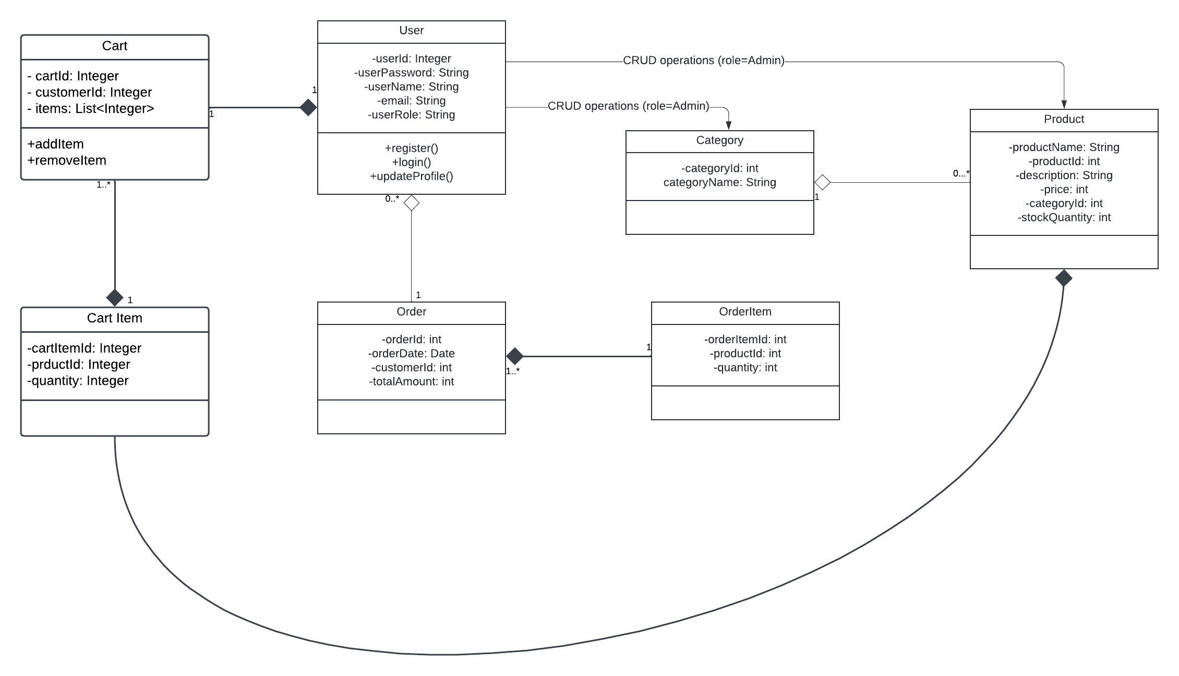

## ERD diagram

